AirTanker Wellbeing Services
The following services are offered free to AirTanker Pilots Sponsored Reservist (SR) and Civilian employees. All services are subject to change.
- AXA Services

- Online Health Gateway
Requires registering online at www.axappphealthcare.co.uk/airtanker using Entitlement Code: E4B9-6GH8.
Focus on health and wellbeing aiming to support boosting fitness levels, nutrition, lifestyle, mindset or better manage stress. Supporting better lifestyle choices on staff’s own terms. Discover practical tools and tips on how to lead a healthier lifestyle by taking a Health Age questionnaire and earn rewards and discounts on supplements, health foods, sportswear or fitness trackers with every healthy action you undertake and log.
- Know Your Numbers (KYN) assessments
15 minute physiologist one to one assessments where staff’s height, weight, BMI, blood pressure, total/HDL ratio, blood glucose, resilience and resting heart rate. Assessments days are held at The Hub RAF Brize Norton, Manchester and London offices. KYN days are promoted in advance and to book an appointment log into the online Health Gateway and book a 15 minute slot via the More > Proactive Connect toolbar.
A follow up telephone one to one Personal Wellbeing Session (PWS) and face to face Health Coaching may be offered free of charge to members of staff requiring additional support to reach their goals
- Group Income Protection (GIP) Scheme – provider UNUM
Regular replacement income, amount of income to be determined, if someone is unable to work because of illness or injury, typically after 6 months long-term sickness absence and upon assessment and approval of claim.
GIP provides a proactive and preventative Employee Assistance Programme (EAP) to help avoid long-term sickness absence.
- Employee Assistance Programme (EAP) - provided by UNUM

- Help@hand Mobile App - provides 4 services delivered by “SQUAREHEALTH”. This is a new service provided by UNUM that AirTanker will introduce in April 2020. It requires individual registration to access the App services. We are currently going through GDPR/DPIA approval process & await an entitlement code:
  - Remote GP
    - For employees, their partner and eligible children* (*up to 18 or 23 if in full-time education)
    - Unlimited access to a UK-based Remote GP
    - Aims to provide access within two hours of the individual requesting an appointment
    - Each video consultation lasts up to 20 minutes
    - Available 24/7, 365 days a year

  - Second opinion
    - Two consultations per year shared between employees, their partner and eligible children* (*up to 18 or 23 if in full-time education)
    - Second opinions with a UK-based specialist, following a diagnosis from a treating doctor
    - Available either face-to-face or via video consultation

  - Mental health support
    - Up to eight consultations (including initial assessments) per year to be shared between the employee and their partner
    - Delivered either face-to-face or supported computerised cognitive behavioural therapy (CBT) based on clinical need following video consultation
    - An assigned therapist throughout

  - Physiotherapy
    - Up to eight consultations (including initial assessments) per year available to be shared between the employee and their partner
    - Delivered either face-to-face or digitally, based on clinical need following a video consultation
    - An assigned physiotherapist throughout
- Lifeworks online
UNUM provide a comprehensive EAP package of work/life confidential support services to AirTanker employees and their immediate family members. The service provides a wealth of information covering personal support, referrals to local child and elder care services, confidential consultation (parenting, work matters, debt management and healthy eating), personal legal support (consumer advice, debt advice, financial law, motoring offences, disputes, wills & probate, criminal, family & medical law, neighbour disputes and personal injury). A wealth of education and information resources can be accessed via the website.
Access to services can be obtained via:
- Tel: 0800 0482702 confidential support 24 hours a day, 365 days a year
- Website www.unumlifeworks.co.uk User ID: unum Password: lifeworks
- Look for “Lifeworks” iPhone app here, or the Android app here User ID: unum Password: lifeworks

- Vocational Rehabilitation Consultants (VRC)
Early intervention and In and Out of work support to employers and employees to help lesson and reduce the impact of sickness absence for employees who become ill or injured. VRC’s offer a wide range of support, guidance and expertise to help staff get back to health.
The early intervention helpline gives both employers and employees direct access to VRCs. This allows them to help tackle health issues at an early stage before problems escalate.
As well as a VRC qualification, such as the CDMP (Certified Disability Management Professional), VRC’s expertise cover a wide range of professional areas, including occupational therapy, occupational psychology, physiotherapy and nursing ensuring variety of illnesses and concerns can be handled effectively, whilst focusing on supporting the person to return to work in the most appropriate way.
Specialist workplace assessments include:
- Dyslexia vocational evaluation
- Functional (physical) capacity
- Psychometric (mental) evaluation – case by case basis
- Ergonomic evaluation
- Mental Health Pathway
Early interventions for staff experiencing difficulties with their mental health. Can be accessed direct by staff – service can provide counselling (up to 4 sessions) online information & wellbeing resources and Cognitive Behavioral Therapy. Accessed via consultation with a Lifeworks consultant.
- Medicash – health care cash plan. Covers everyday healthcare costs such as consumer discounts, Best Doctors (expert medical information & advice) dental treatments, optical bills, specialist consultations, diagnostic tests, PMI excess, complimentary & alternative therapies, chiropody, hospital stay, prescriptions, inoculations & flu jab and health screening:
Benefits table
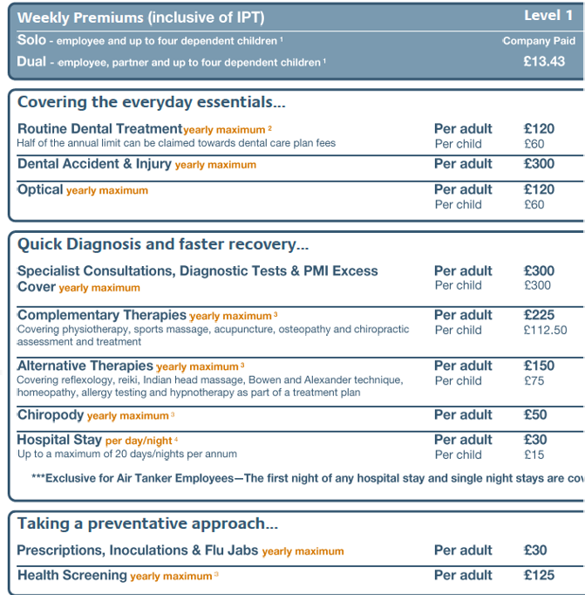

- Occupational Health Services – Staff are referred through HR or Line Manager – offers physical and mental health wellbeing support
- Death in Service Insurance – provided by AIG
AIG provides the following free & confidential wellbeing services:
- Bereavement Counselling – available to all employees and their immediate family;

  - Support strategies to manage anxiety or other mental health issues
  - Referral to bereavement support groups
  - A dedicated listening service to help cope with grief after an unexpected or accidental death
  - Referred to a therapy resource for continued support
  - Support in understanding and coping with the loss of a loved one
  - Up to 4 face to face or telephone counsellor sessions
  - 24/7 bereavement helpline 0800 069 8856 Outside of UK +44 141 846 0217

- Probate Helpline Support helpline – provided by Winston’s Wish available to all employees and their immediate family;

  - Explaining the process for obtaining probate after a death
  - Providing guidance to help deal with legal, financial and tax issues following death
  - Helping the employee or family navigate the administrative issues resulting from a death
  - Access to support guides and articles to help deal with grief and loss
  - Unlimited access to a probate helpline 0800 069 8856 Outside of UK +44 141 846 0217

- Smart Health – unlimited employee, immediate family, and children up to the age of 21, access to six Smart Health Services, available 24/7 365 days a year online https://www.aiglife-smarthealth.com/ :

  - 24/7 GP
  - A second medical opinion
  - A health check
  - Nutritional consultation
  - An online fitness programme
  - Mental health support – support coping with stress, anxiety, trauma, depression or a recent bereavement and offering one time consultations delivered remotely in the comfort of your own home or wherever you are in the world. You may need up to four therapy sessions before the specialist is able to recommend the right coping strategies for you.
    - Request online or telephone consultation: Access online via: https://www.aiglife-smarthealth.com/en/mental-health-support/ using Entitlement code LG006354

- Bupa Health Insurance Scheme
The scheme covers elderly care support line, consultations, out-patient, in-patient, cancer & mental health treatment, overseas emergency treatment costs, repatriation & evac costs, cash benefits, treatment at home, home nursing and private ambulance charges (please see attached benefits table).
Bupa anytime HealthLine - Whatever your health question or concern – from advice about symptoms, to information on leading a healthier lifestyle – you can speak to a nurse, 24 hours a day, seven days a week. You can ask us questions about anyone in your family, they don’t have to be on your policy.

Telephone numbers:
- For health advice Call 0345 607 7777
- For all claims and cover enquiries call 0345 266 6051
- For elderly care advice Call 0330 134 6696
Mental Health Treatment
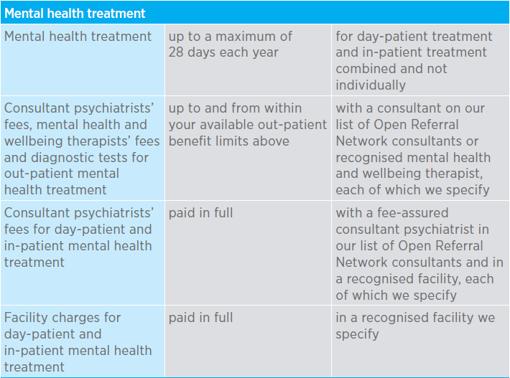
- Headspace Meditation App
Free Headspace App service to AirTanker employees.
Download the Headspace app and Log In with your login details. All AirTanker staff must sign up via https://work.headspace.com/airtanker/join and register/sign up with your AirTanker or personal email address and activate your account via the registration email received in your inbox and follow the steps. If you already have a Headspace account you can merge
Difficulty subscribing?
Contact the Headspace Support Team @ help.headspace.com
Technical issues submit a ticket through the community site or email: Teamsupport@headspace.com
- HR
The following HR departments can be approached for confidential advice, guidance and support; HR Services, HR Operations Managers, HR advisers and Welfare Manager
- Infrastructure
By June 2020 AirTanker will have a Wellbeing Room situated in the Refueller Café which will provide space for meditation, reflection and a wellbeing reference/information library
- RAF Brize Norton Support Services
Eligible to Sponsored Reservists and Armed Forces Veterans/Retirees (signposting services to civilians only)
- Citizens Advice Bureau – RAFBrizeNorton@citizensadvicewestoxon.org.uk
- RAF Brize Norton Chaplaincy – Clerk contact: 01993 896543
- RAF Brize Norton Gymnasium (01993 897908) & Swimming Pool (01993 845128)
- RAF Brize Norton Community Support –https://www.raf.mod.uk/our-organisation/stations/raf-brize-norton/facilities/
- Military Charities – Eligible to Sponsored Reservists and Armed Forces Veteran/Retired
  - SSAFA - www.ssafa.org.uk
  - RAF Benevolent fund – www.rafbf.org
  - RAF Associations – www.rafa.org.uk
  - Combat stress – www.combatstress.org.uk
  - Help for heroes – www.helpforheroes.org.uk
  - RAF Families Federation – www.raf-ff.org.uk
  - Armed Forces Charities Directory - https://armedforcescharities.org.uk/Public/Search_the_database/Public/Directory.aspx?hkey=23259e39-2b97-4644-b2f7-e05191b78bb9

- AirTanker provided Wellbeing Training Services
In 2020 AirTanker will be providing the following wellbeing training:
- Mental Health Awareness Computer Based Training for all staff and Line Managers
- Wellbeing Champion Training
- Loss & Bereavement Trg to Champions and Line Managers
- Sustaining Resilience at Work (StRaW) and Trauma Risk Management (TRiM) to Emergency Response Teams and Mental Wellbeing Champions
- RAF Association RAF Association Mental Wellbeing Courses for non-serving members of the RAF family offering practical steps to overcome life’s challenges: book online at rafa.org.uk/finding-it-tough Call 0800 0182361 or email FIT@rafa.org.uk

